UNDER EMBARGO UNTIL 8th Jan. 15:00 PST
MSI Unveils Waves of AI-Ready Laptops & Its First Gaming Handheld at CES 2024
Powered By The Brand New Inte^{l®} Core™ Ultra & Refreshed 14th Gen HX-series processors
[DATELINE] (TAIPEI, TAIWAN) - With the zeitgeist of AI technology taking the world by storm, MSI, a world-leading premium laptop brand, has taken it in stride through its professionalism over luxurious aesthetics, extreme performance and innovative technology. Announcing the latest AI-powered laptops lineup, with the NPU(Neural Processing Unit) built-in Intel® Core™ Ultra processor. MSI has also introduced its pioneering gaming handheld device, Claw, the first handheld equipped with the Intel Core™ Ultra Processor. Additionally, MSI has launched a series of 18” laptops featuring Intel® 14th Gen HX-series processors and the largest vapor chamber thermal modules, aiming to be the most powerful on the planet. The lineup also expands the use of 14th Gen HX-series processors across its new mainstream gaming and creator models, all equipped with the full power of RTX 40 series graphics and class-leading 6 vents for heat dissipation, providing immersive gameplay & smooth creation to users.
“We are excited to delve into AI, especially with how prevalent it is today,” said Eric Kuo, the Executive Vice President & NB BU GM of MSI. “MSI strives to stay ahead of the curve, and with our new AI-powered laptops, we are further establishing ourselves as a brand heeding our customers’ needs.”

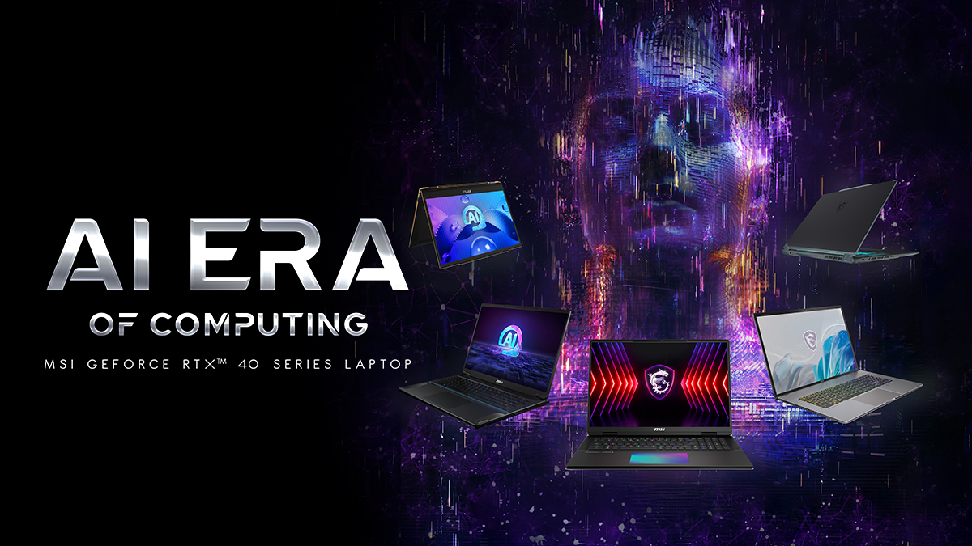
“We’re proud to partner with MSI to deliver unparalleled experiences for users around the globe. The new MSI Claw is an exciting new gaming handheld powered by an Intel Core Ultra processor that provides an unparalleled gaming experience to be enjoyed anywhere, anytime. And, the MSI Titan 18 HX, powered by our new Intel Core 14th gen HX processor, offers some of the most immersive mobile gameplay experiences possible. With the launch of these new processors we are providing gamers, creators and professionals the compute performance they need and expect from Intel and MSI.” – Michelle Johnston Holthaus, Executive Vice President and GM, Client Computing Group, Intel

Intel® Core™ Ultra: Built for Sustained AI Workloads
The latest MSI Laptops, powered by the new Intel® Core™ Ultra processors, are designed for sustained AI workloads. These processors feature a dedicated Neural Processing Unit (NPU) optimized for AI tasks and are built on the brand new Intel 4 process node. The Core™ Ultra's Low Power Efficient (LPE) cores ensure minimal power usage for routine tasks, enhancing battery life. Additionally, the integration of ARC™ graphics in the Core™ Ultra offers more than double the graphical performance per watt compared to previous generations, supporting not only standard office applications and streaming but also light content creation and gaming.
Intel® Core™ i9 Processor (14th gen HX-series): Built for Fast Response AI Workloads
MSI introduces a new series of high-performance laptops equipped with the 14th gen Intel® Core™ HX-series processors, the most potent mobile processors to date, ideal for AI workloads requiring quick response, light weight, and low latency. These processors reach an unprecedented 5.8 GHz clock speed, the highest in mobile processors. Further enhanced with the exclusive Intel® Application Optimizer for thread optimization in gaming, these MSI laptops offer unparalleled performance for immersive gaming and demanding content creation.
NVIDIA® GeForce RTX™ GPU: Built for Performance-demanding AI
NVIDIA® GeForce RTX™ inside MS Laptops are built for the era of AI. Powered by NVIDIA’s industry-leading Ada Lovelace architecture, RTX GPUs feature AI-powered DLSS 3 and deliver lifelike virtual worlds through full ray tracing capabilities. The specialized AI Tensor Cores deliver cutting-edge performance and transformative capabilities for AI in gaming, creating, everyday productivity, and more. With RTX, you unlock the full potential of AI on Windows PCs today and in the future.
MSI AI Software Suite: AI Engine, AI Artist, & AI Noise Cancellation Pro
MSI is not just embracing AI-ready hardware but also launching exclusive AI-driven software, marking its commitment to the AI era. The AI Engine enhances user experience by automatically optimizing laptop settings such as display, audio, power profiles, and keyboard backlight based on the application used, ensuring immersive entertainment and efficient content creation.
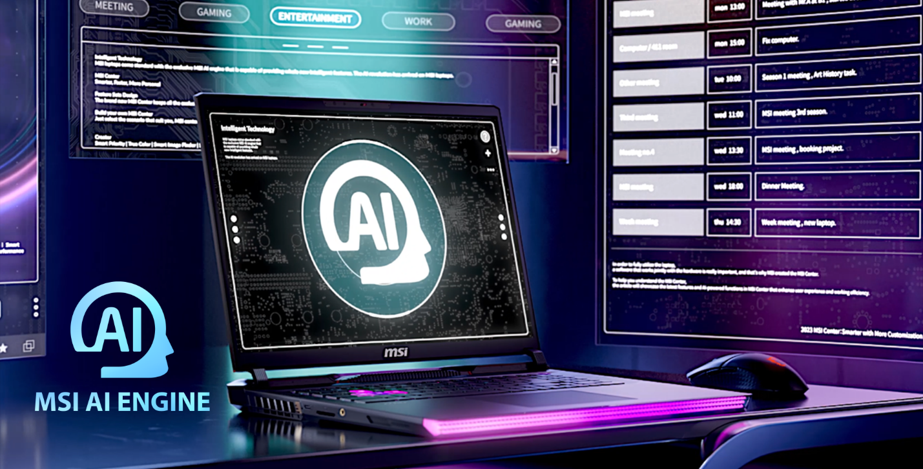
The AI Artist, a rare offline text-to-image service, eliminates network latency and data leakage risks and utilizes the performance of the powerful laptops, offering additional features like image-to-image, image-to-text, and exporting layered PSD files for Photoshop editing, greatly boosting productivity for content creators.
Additionally, the AI Noise Cancellation Pro, which merges advanced microphone hardware with AI-powered noise cancellation software, delivers studio-quality voice for remote meetings or professional recording, even in noisy environments, with customizable microphone pickup positions.
New 18-inch Gaming Laptops Family: Titan 18 HX/ Raider 18 HX / Stealth 18 AI Studio
MSI proudly introduces its newly designed 18-inch gaming laptop family, featuring the dual CES award-winning Titan 18 HX, the extreme performance powerhouse Raider 18 HX, and the lightweight 18-inch gaming laptop Stealth 18 AI Studio. To showcase extreme performance, both the Titan 18 HX and Raider 18 HX are equipped with top-notch Intel 14th gen Core™ i9 processors and NVIDIA® GeForce RTX™ 40 Series graphics, while the Stealth 18 AI Studio boasts the latest Intel Core™ Ultra processors. Furthermore, the Titan 18 HX features the biggest new vapor chamber cooler thermal solution in the market and supports MSI OverBoost Ultra, delivering an industry-first 270W total power, while the Raider 18 HX provides an impressive 250W full total power.
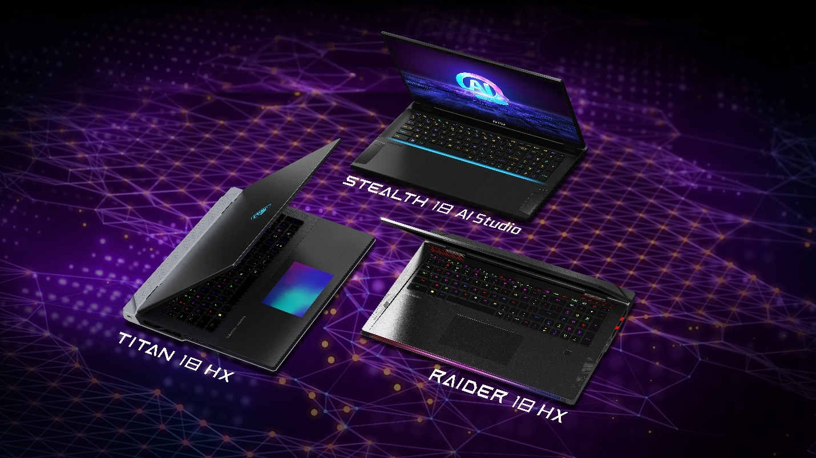
In delivering an immersive gaming experience, the Titan 18 HX, Raider 18 HX, and Stealth 18 AI Studio all feature a brand-new 18-inch large display for a borderless gaming horizon. Standout features include the world's first 18-inch 4K 120Hz mini LED display, offering ultra-high resolutions, DisplayHDR 1000, and wide color gamut coverage for a vivid, lifelike gaming experience.
Every model in the lineup, including the Titan 18 HX, Raider 18 HX, and Stealth 18 AI Studio, features a fresh product design. The Titan 18 HX highlights a user-centric approach with the world's first Seamless RGB Haptic Touchpad and a revamped Cherry Switch Mechanical Keyboard. The Titan 18 HX features four sets of expansion memory slots, the total capacity can be extended to an impressive 128GB. Additionally, it includes three M.2 SSD slots, providing a storage capacity of up to 12TB. The redesigned Raider 18 HX boasts the iconic matrix light bar and a new 3D stand to optimize cooling airflow, enhancing overall performance. The Titan 18 HX and Stealth 18 AI Studio stands out for its construction with a magnesium-aluminum alloy, ensuring durability and a sleek aesthetic, making the Stealth 18 AI Studio the lightest 18-inch gaming laptop available in the market.
World’s first Meteor Lake-powered gaming handheld: Claw
MSI proudly introduces the Claw, a groundbreaking handheld gaming device that marks a new era in portable gaming experiences. Powered by Intel Core™ Ultra processors and featuring Intel XeSS technology, it significantly enhances FPS, ensuring a smooth and immersive gameplay experience even on AAA titles. The Claw is equipped with MSI Cooler Boost Hyperflow thermal technology, the intraflow thermal design redirects the airflow to cool the internal components, ensuring optimal gaming performance even in the palm of your hand.
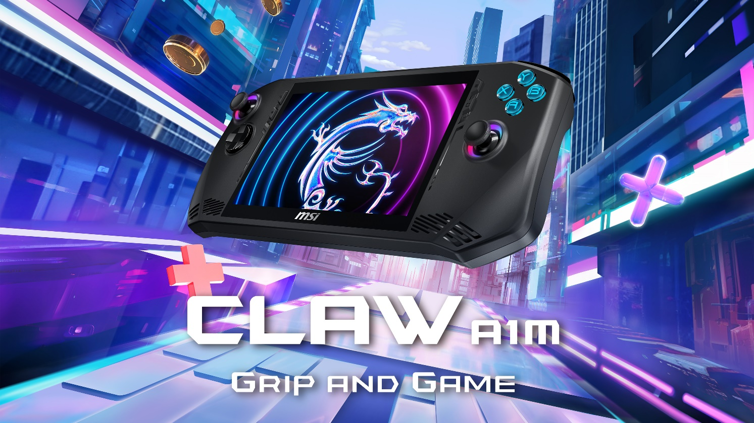
The MSI Claw sets a new standard with its large 53Whr battery capacity, the largest in its class, providing an impressive 2-hour battery life under full workload conditions. This allows gamers to enjoy extended sessions without worrying about running out of power.
Featuring the all-new user-friendly UI design, MSI Center M, the Claw provides an intuitive platform for easy access to essential features and settings. The quick game launcher and instant platform access streamline the installation and downloading process. The Claw also supports MSI APP Player, offering not only Windows games but also access to Android mobile games.
Ergonomically-tailored for comfort and precision, the Claw is designed to fit the natural contours of your grip, providing an intuitive gaming experience for hands of all sizes. Boasting a 7-inch Full HD touchscreen display with a refresh rate of up to 120 Hz, the MSI Claw ensures a visually stunning and responsive gaming environment.
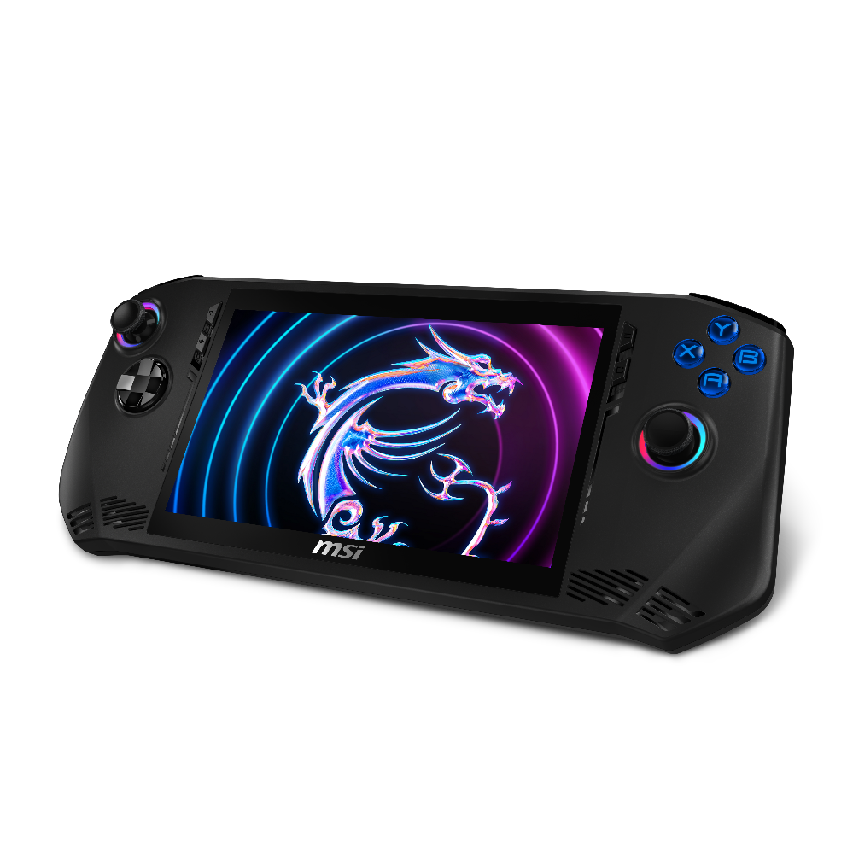
"In our commitment to enhancing the gaming experience for our users, we aim to address market pain points and dedicate efforts to the handheld space,” said Eric Kuo, the Executive Vice President& NB BU GM of MSI. “We have fine-tuned specific designs tailored exclusively for gamers, debuting our very first handheld, Claw, which redefines the standards in the handheld market."

Full Power Gaming Laptop: Vector HX/ Crosshair HX/ Pulse AI
The new Vector 16/17 HX, Crosshair 16/17 HX, and Pulse 16/17 AI all released with full GPU power, offering gamers an uncompromised performance experience. Notably, the Vector 17 HX is equipped with MSI Overboost technology, providing a total power output of 250W for unprecedented gaming capabilities. MSI's new Crosshair HX and Pulse AI series laptops feature a total of 6 exhaust and 2 intake ports. This innovative thermal design enhances the airflow to ensure optimal performance.
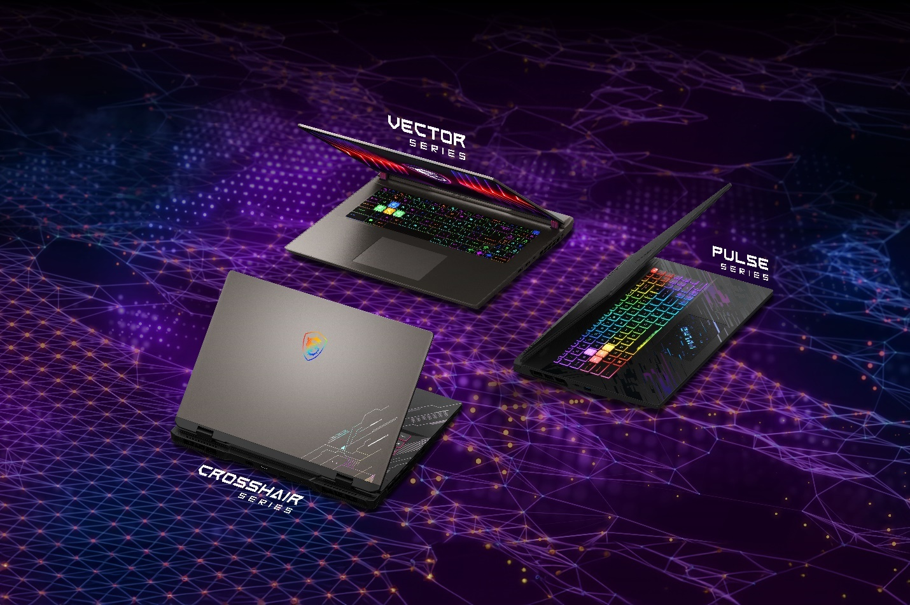
The Crosshair 16/17 HX and Pulse 16/17 AI models showcase MSI's commitment to cutting-edge design, featuring a brand-new aesthetic with a 24-zone RGB keyboard backlight that elevates the gaming environment with stylish illumination. The Crosshair 16/17 HX stands out with its futuristic spacecraft pattern, while Pulse 16/17 AI introduces a groundbreaking electromagnetic pulse pattern, reflecting the future of laptop design, where style and innovation harmonize in a pulsating synergy.
For Mainstream Gamer: Sword HX/ Cyborg/ Thin 15
MSI has expanded its gaming laptop lineup for the mainstream. The Sword 16/17 HX, in space grey with PCR materials, offers an immersive gaming experience and a 24-zone RGB backlit keyboard. The Cyborg 15 AI, with the latest Intel Core™ Ultra processor, boasts a futuristic translucent chassis for style and performance. The Thin 15, in cosmos grey, presents a sleek gaming option with a portable design and a translucent WASD blue backlit keyboard. MSI's diverse selection includes the Cyborg 14, an accessible 14-inch alternative for users seeking both style and functionality.
Thin and Powerful Productivity: Prestige 16 AI/ Prestige 14 AI/ Prestige 13 AI
Introducing the Prestige AI series, powered by the latest Intel Core™ Ultra processors. Leading the lineup is the ultralight Prestige 16 AI, weighing only 1.5kg. Crafted with a magnesium-aluminum alloy, it houses a robust 99.9WHr battery for a remarkable 19hrs battery life. The Prestige 14 AI follows suit with a thin and powerful design, featuring the largest battery (90Whrs) in the 14-inch class. Both models, available in 16-inch and 14-inch versions, support up to PD 3.1 140W Charging for long-lasting productivity.
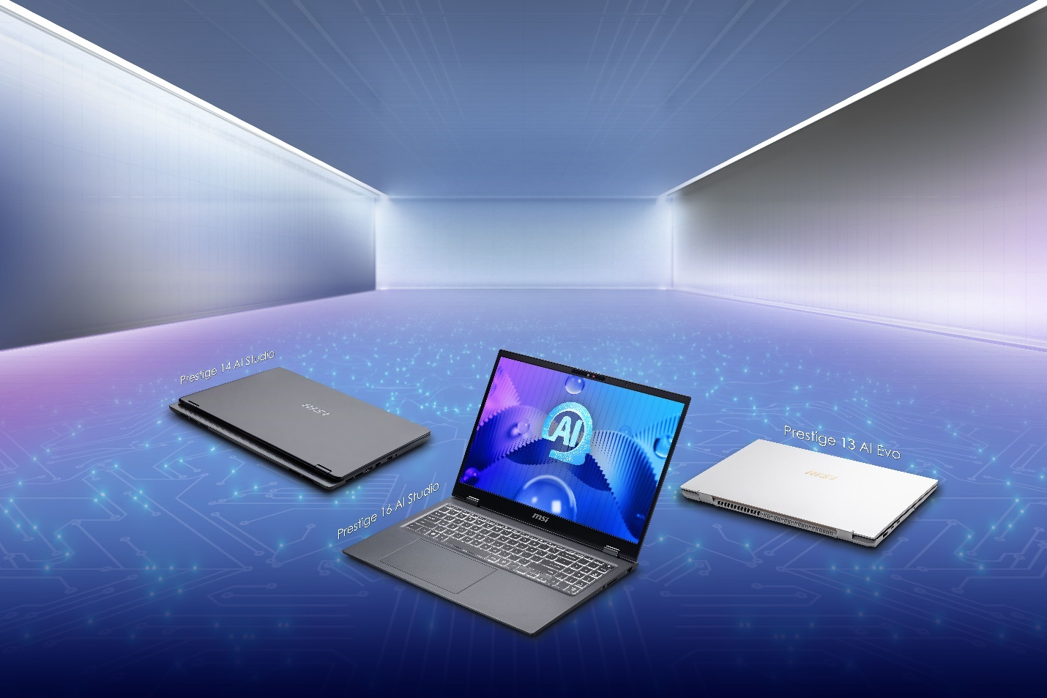
Certified by Intel Evo and Nvidia Studio, the Prestige 16 AI and Prestige 14 AI series combine high performance and lightweight portability. Incorporating the NVIDIA® GeForce RTX™ 40 series Laptop GPU, these laptops deliver top-notch performance for creative applications. The Prestige 13 AI Evo, an ultralight powerhouse at 990g, boasts a remarkable 75WHrs battery, up to 50% larger in capacity compared to similar laptops. Both the Prestige 16 AI and Prestige 13 AI Evo feature stunning 16:10 OLED displays with 100% DCI-P3 Color gamut coverage for true-to-life visual excellence.
Made for Content Creators: Content Creation Series
MSI has also refreshed its content creation product line with the new Creator Z17 HX Studio, Creator 16 AI Studio, Creator M14, and Creator M16 HX. The Creator Z17 HX Studio featuring a vapor chamber cooler thermal design that positions it as the most powerful content creation laptop in the lineup. The brand-new Creator 16 AI Studio also features a 16:10 OLED display, enhancing the visual experience, and ensuring creators can bring their visions to life with unparalleled accuracy. Weighing less than 2 kg, the Creator 16 stands as a portable powerhouse and is an ideal solution for creative professionals who require an easy-to-carry laptop. Expanding the range of choices for content creation laptops, MSI introduces the Creator M14 and Creator M16 HX. These additions provide creators with a wider selection, catering to diverse preferences and requirements in the content creation space.
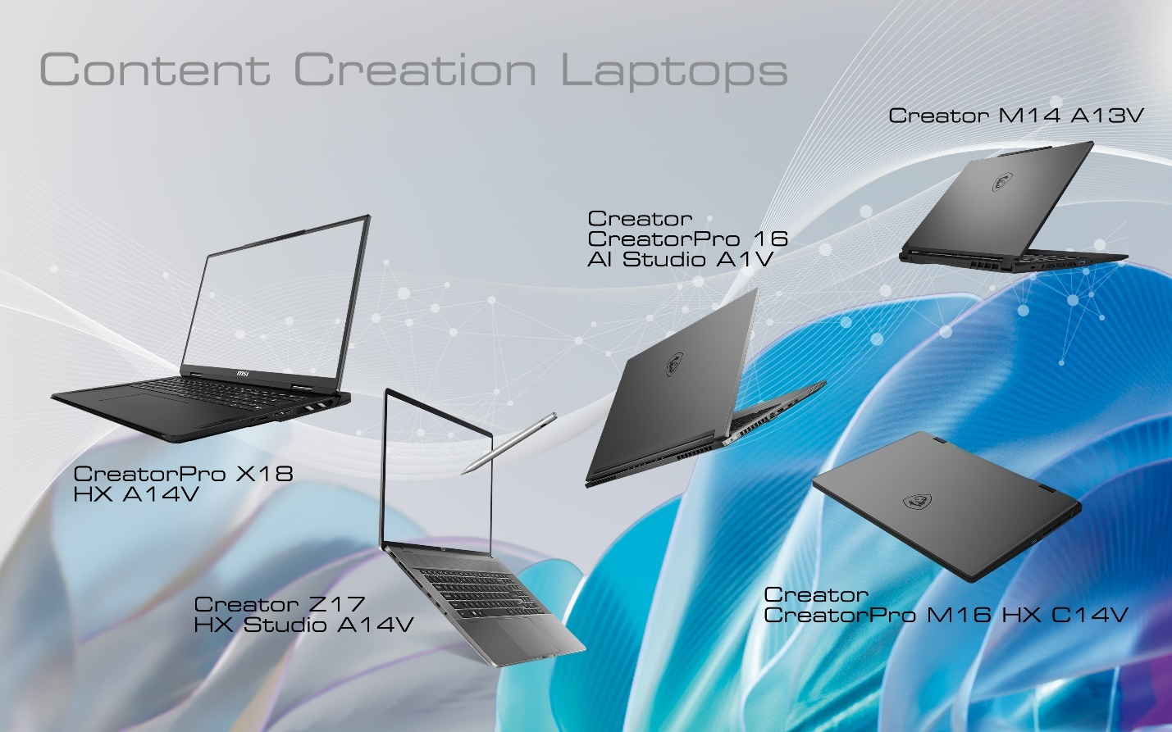
MSI persists in expanding its laptop portfolio, pushing the limits of both extreme performance and aesthetic design. The introduction of brand-new AI laptops, coupled with MSI's exclusive AI features, marks a significant step forward, ushering individuals into the AI era of computing.

Model Name | Titan 18 HX A14VIG / A14VHG
Processor | Intel® Core™ i9 processor 14900HX
Operating System | Windows 11 Home / Windows 11 Pro (MSI recommends Windows 11 Pro for business.)
Chipset | Intel® HM770
Memory | DDR5, 4 Slots, up to 128GB
Display | 18" UHD+ (3840x2400), 16:10, MiniLED, 120Hz Refresh Rate, 100% DCI-P3 (Typ.), VESA DisplayHDR™ 1000 Certified, IPS-Level panel
Graphics | NVIDIA® GeForce RTX™ 4090 Laptop GPU 16GB GDDR6 (A14VIG)  NVIDIA® GeForce RTX™ 4080 Laptop GPU 12GB GDDR6 (A14VHG)
Storage Slots | 1 x NVMe M.2 SSD by PCIe Gen5 x4  2 x NVMe M.2 SSD by PCIe Gen4 x4
Keyboard | Cherry Mechanical Per-Key RGB gaming keyboard by SteelSeries
Audio | 6 Speaker designed by Dynaudio system (4 x 2W Speakers + 2 x 2W Woofers)  1 x Audio combo jack  Nahimic 3 Audio Enhanc  Hi-Res Audio ready
USB Ports | 1 x Thunderbolt™ 4 / DP/ USB Type-C (w/ PD 3.1), 1 x Thunderbolt™ 4 / DP/ USB Type-C,  3 x USB 3.2 Gen2 Type-A
Card Reader | 1 x SD Express Memory Card Reader
Video Output | 1 x Thunderbolt™ 4 / DP/ USB Type-C (w/ PD 3.1), 1 x Thunderbolt™ 4 / DP/ USB Type-C  1 x HDMI™ 2.1 (8K@60Hz / 4K@120Hz)
Communication | Intel® Killer™ Ethernet E3100 (up to 2.5 GbE) / Intel® Killer™ Wi-Fi 7 BE1750, Bluetooth v5.4
Webcam | IR FHD type (30fps@1080p) with HDR & 3D Noise Reduction+ (3DNR+)
Security | IR Webcam / Firmware Trusted Platform Module(fTPM) 2.0 / Webcam Shutter / Kensington Lock
Battery | 4-Cell, Li-Polymer, 99.9Whr
Power Adapter | 400W
Dimension | 404 (W) x 307.5 (D) x 24~32 (H) mm
Weight | 3.6 Kg

Model Name | Raider 18 HX A14VIG/ A14VHG / A14VGG / A14VFG
Processor | Intel® Core™ i9 processor 14900HX
Operating System | Windows 11 Home / Windows 11 Pro  (MSI recommends Windows 11 Pro for business.)
Chipset | Intel® HM770
Memory | DDR5, 4 Slots, up to 128GB
Display | 18" UHD+ (3840x2400), 16:10, MiniLED, 120Hz Refresh Rate, 100% DCI-P3 (Typ.), VESA DisplayHDR™ 1000 Certified, IPS-Level panel
Graphics | NVIDIA® GeForce RTX™ 4090 Laptop GPU 16GB GDDR6 (A14VIG)  NVIDIA® GeForce RTX™ 4080 Laptop GPU 12GB GDDR6 (A14VHG)  NVIDIA® GeForce RTX™ 4070 Laptop GPU 8GB GDDR6 (A14VGG)
Storage Slots | 1 x NVMe M.2 SSD by PCIe Gen5 x4  1 x NVMe M.2 SSD by PCIe Gen4 x4
Keyboard | Per-Key RGB gaming keyboard by SteelSeries
Audio | 6 Speaker designed by Dynaudio system (4 x 2W Speakers + 2 x 2W Woofers)  1 x Audio combo jack  Nahimic 3 Audio Enhance  Hi-Res Audio ready
USB Ports | 1 x Thunderbolt™ 4 / DP/ USB Type-C (w/ PD 3.1), 1 x Thunderbolt™ 4 / DP/ USB Type-C,  3 x USB 3.2 Gen2 Type-A
Card Reader | 1 x SD Express Memory Card Reader
Video Output | 1 x Thunderbolt™ 4 / DP/ USB Type-C (w/ PD 3.1), 1 x Thunderbolt™ 4 / DP/ USB Type-C  1 x HDMI™ 2.1 (8K@60Hz / 4K@120Hz)
Communication | Intel® Killer™ Ethernet E3100 (up to 2.5 GbE) / Intel® Killer™ Wi-Fi 7 BE1750, Bluetooth v5.4
Webcam | IR FHD type (30fps@1080p) with HDR & 3D Noise Reduction+ (3DNR+)
Security | IR Webcam / Firmware Trusted Platform Module(fTPM) 2.0 / Webcam Shutter / Kensington Lock
Battery | 4-Cell, Li-Polymer, 99.9Whr
Power Adapter | 330W
Dimension | 404 (W) x 307.5 (D) x 24~32 (H) mm
Weight | 3.6 Kg

Model Name | Stealth 18 AI Studio A14VIG/ A14VHG / A14VGG
Processor | Intel® Core™ Ultra 9 processor 185H
Operating System | Windows 11 Home (MSI recommends Windows 11 Pro for business.)  Windows 11 Pro
Chipset | Integrated SoC
Memory | DDR5, 2 slots, up to 64GB
Display | 18" UHD+ (3840x2400), 16:10, MiniLED, 120Hz Refresh Rate, 100% DCI-P3 (Typ.), VESA DisplayHDR™ 1000 Certified, IPS-Level panel
Graphics | NVIDIA® GeForce RTX™ 4090 Laptop GPU 16GB GDDR6 (A14VIG)  NVIDIA® GeForce RTX™ 4080 Laptop GPU 12GB GDDR6 (A14VHG)  NVIDIA® GeForce RTX™ 4070 Laptop GPU 8GB GDDR6 (A14VGG)
Storage Slots | 2 x NVMe M.2 SSD by PCIe Gen4 x4
Keyboard | Per-Key RGB Gaming Keyboard by SteelSeries
Audio | 2 x 2W Speakers and 4 x 2W Woofers designed by Dynaudio system  1 x Audio combo jack  Nahimic 3 Audio Enhancer  Hi-Res Audio ready
USB Ports | 1 x Thunderbolt™ 4 / DP/ USB Type-C (w/ PD 3.1), 1x USB 3.2 Gen2 Type-C / DP,  2 x USB 3.2 Gen2 Type-A
Card Reader | 1 x SD Express Memory Card Reader
Video Output | 1 x Thunderbolt™ 4 / DP/ USB Type-C (w/ PD 3.1), 1 x USB 3.2 Gen2 Type-C / DP,  1 x HDMI™ 2.1 (8K@60Hz / 4K@120Hz)
Communication | Intel® Killer™ Ethernet E3100 (up to 2.5 GbE) / Intel® Killer™ Wi-Fi 7 BE1750, Bluetooth v5.4
Webcam | IR FHD type (30fps@1080p) with HDR & 3D Noise Reduction+ (3DNR+)
Security | IR Webcam / Fingerprint Reader / Firmware Trusted Platform Module(fTPM) 2.0 /  Webcam Shutter / Kensington Lock
Battery | 4-Cell, Li-Polymer, 99.9Whr
Power Adapter | 280W adapter
Dimension | 399.9 (W) x 289.6 (D) x 19.9-23.9 (H) mm
Weight | 2.79 Kg

Model Name | Claw A1M
Processor | Up to Intel® Core™ Ultra 7 processor 155H
Operating System | Windows 11 Home (MSI recommends Windows 11 Pro for business.)  Windows 11 Pro
Chipset | Integrated SoC
Memory | LPDDR5 onboard, 16GB, dual channel
Display | 7" FHD (1920 x 1080), 120 Hz Refresh Rate, Touch Screen, 120 Hz Refresh Rate, 100% sRGB(Typical), 500nits(Typical), IPS-Level panel
Graphics | Intel® Arc Graphics
Storage Slot | 1 x NVMe M.2 2230 SSD by PCIe Gen 4 x4
Sensor | 6-Axis IMU Vibration Motor
Communication | Intel® Killer™ Wi-Fi 7 BE1750, Bluetooth v5.4
Audio | 2 × 2W Speakers / 1× Audio combo jack / Hi-Res Audio ready
I/O Port | 1 x Thunderbolt™ 4 / DP/ USB Type-C (w/ PD 3.0 Charging)  1 x microSD Card Reader  1 x Audio combo jack  1x Power button with Finger Print Sensor
Battery/Adapter | 6-Cell, Li-Polymer, 53Whr / 65W USB Type-C PD 3.0
Dimension | 294 (W) x 117(D) x 21.2(H) mm
Weight | 675 g
Color | Black

Model Name | Vector 17 HX A14VHG / A14VGG / A14VFG | Vector 16 HX A14VHG / A14VGG / A14VFG
Processor | Intel® Core™ i9 processor 14900HX | Intel® Core™ i9 processor 14900HX
Operating System | Windows 11 Home (MSI recommends Windows 11 Pro for business.)  Windows 11 Pro | Windows 11 Home (MSI recommends Windows 11 Pro for business.)  Windows 11 Pro
Chipset | Intel® HM770 | Intel® HM770
Memory | DDR5, 2 slots, up to 64GB | DDR5, 2 slots, up to 64GB
Display | 17“ QHD+ (2560x1600), 16:10, 240 Hz Refresh Rate, 100% DCI-P3(Typical), IPS-Level panel | 16" QHD+ (2560x1600), 16:10, 240Hz Refresh Rate, 100% DCI-P3(Typical), IPS-Level panel
Graphics | NVIDIA® GeForce RTX™ 4080 Laptop GPU 12GB GDDR6 (A14VHG)  NVIDIA® GeForce RTX™ 4070 Laptop GPU 8GB GDDR6 (A14VGG)  NVIDIA® GeForce RTX™ 4060 Laptop GPU 8GB GDDR6 (A14VFG) | NVIDIA® GeForce RTX™ 4080 Laptop GPU 12GB GDDR6 (A14VHG)  NVIDIA® GeForce RTX™ 4070 Laptop GPU 8GB GDDR6 (A14VGG)  NVIDIA® GeForce RTX™ 4060 Laptop GPU 8GB GDDR6 (A14VFG)
Storage Slots | 1 x NVMe M.2 SSD by PCIe Gen5 x4  1 x NVMe M.2 SSD by PCIe Gen4 x4 | 1 x NVMe M.2 SSD by PCIe Gen5 x4  1 x NVMe M.2 SSD by PCIe Gen4 x4
Keyboard | Per-Key RGB gaming keyboard by SteelSeries | Per-Key RGB gaming keyboard by SteelSeries
Audio | 2 x 2W Stereo Speakers  1 x Audio combo jack  Nahimic 3 Audio Enhance  Hi-Res Audio ready | 2 x 2W Stereo Speakers  1 x Audio combo jack  Nahimic 3 Audio Enhancer  Hi-Res Audio ready
USB Ports | 1 x Thunderbolt™ 4 / DP/ USB Type-C, 1x USB 3.2 Gen2 Type-C/DP (w/ PD 3.0 Charging)  1 x USB 3.2 Gen2 Type-C / DP ,1 x USB 3.2 Gen2 Type-A, 1 x USB 3.2 Gen1 Type-A | 1 x Thunderbolt™ 4 / DP/ USB Type-C, 1x USB 3.2 Gen2 Type-C / DP (w/ PD 3.0 Charging)  1 x USB 3.2 Gen2 Type-C / DP , 1 x USB 3.2 Gen2 Type-A, 1 x USB 3.2 Gen1 Type-A
Card Reader | 1 x SD Express Memory Card Reader | 1 x SD Express Memory Card Reader
Video Output | 1 x Thunderbolt™ 4 / DP/ USB Type-C, 1x USB 3.2 Gen2 Type-C/DP (w/ PD 3.0 Charging)  1 x USB 3.2 Gen2 Type-C / DP, 1 x HDMI™ 2.1 (8K@ 60Hz / 4K@ 120Hz) | 1 x Thunderbolt™ 4 / DP/ USB Type-C, 1x USB 3.2 Gen2 Type-C / DP (w/ PD 3.0 Charging)  1 x USB 3.2 Gen2 Type-C / DP, 1 x HDMI™ 2.1 (8K@ 60Hz / 4K@ 120Hz)
Communication | Gigabit Ethernet (up to 2.5GbE) / Intel® Killer™ Wi-Fi 7 BE1750, Bluetooth v5.4 | Gigabit Ethernet (up to 2.5GbE) / Intel® Killer™ Wi-Fi 7 BE1750, Bluetooth v5.4
Webcam | HD type (30fps@720p) with 3D Noise Reduction (3DNR) | HD type (30fps@720p) with 3D Noise Reduction (3DNR)
Security | Firmware Trusted Platform Module(fTPM) 2.0 / Webcam Shutter / Kensington Lock | Firmware Trusted Platform Module(fTPM) 2.0 / Webcam Shutter / Kensington Lock
Battery | 4-Cell, Li-Polymer, 90Whr | 4-Cell, Li-Polymer, 90Whr
Power Adapter | 330W (A14VHG ) / 280W (A14VGG / A14VFG) | 330W (A14VHG) / 280W (A14VGG/A14VFG)
Dimension | 380 (W) x 297.97 (D) x 23.55~29.45 (H) mm | 357 (W) x 284 (D) x 22.2~28.55 (H) mm
Weight | 3 Kg | 2.7 Kg

Model Name | Crosshair 17 HX D14VGKG / D14VFKG | Crosshair 16 HX D14VGKG / D14VFKG
Processor | Intel® Core™ i7 processor 14700HX | Intel® Core™ i7 processor 14700HX
Operating System | Windows 11 Home (MSI recommends Windows 11 Pro for business.)  Windows 11 Pro | Windows 11 Home (MSI recommends Windows 11 Pro for business.)  Windows 11 Pro
Chipset | Intel® HM770 | Intel® HM770
Memory | DDR5, 2 slots, up to 64GB | DDR5, 2 slots, up to 64GB
Display | 17" QHD+ (2560x1440), 16:10, 240Hz Refresh Rate, 100% DCI-P3(Typ.), IPS-Level panel | 16" QHD+ (2560x1440), 16:10, 240Hz Refresh Rate, 100% DCI-P3(Typ.), IPS-Level panel
Graphics | NVIDIA® GeForce RTX™ 4070 Laptop GPU 8GB GDDR6 (D14VGKG)  NVIDIA® GeForce RTX™ 4060 Laptop GPU 8GB GDDR6 (D14VFKG) | NVIDIA® GeForce RTX™ 4070 Laptop GPU 8GB GDDR6 (D14VGKG)  NVIDIA® GeForce RTX™ 4060 Laptop GPU 8GB GDDR6 (D14VFKG)
Storage Slots | 1 x NVMe M.2 SSD by PCIe Gen5 x4  1 x NVMe M.2 SSD by PCIe Gen4 x4 | 1 x NVMe M.2 SSD by PCIe Gen5 x4  1 x NVMe M.2 SSD by PCIe Gen4 x4
Keyboard | 24-Zone RGB Gaming Keyboard | 24-Zone RGB Gaming Keyboard
Audio | 2 x 2W Stereo Speakers  1 x Audio combo jack  Nahimic 3 Audio Enhancer  Hi-Res Audio ready | 2 x 2W Stereo Speakers  1 x Audio combo jack  Nahimic 3 Audio Enhancer  Hi-Res Audio ready
USB Port | 1 x USB 3.2 Gen1 Type-C / DP (w/ PD 3.0 Charging)  3 x USB 3.2 Gen1 Type-A | 1 x USB 3.2 Gen1 Type-C / DP (w/ PD 3.0 Charging)  3 x USB 3.2 Gen1 Type-A
Video Output | 1 x HDMI™ 2.1(8K@60Hz / 4K@120Hz), 1 x USB 3.2 Gen1 Type-C / DP | 1 x HDMI™ 2.1(8K@60Hz / 4K@120Hz), 1 x USB 3.2 Gen1 Type-C / DP
Communication | Gigabit Ethernet / Intel® Wi-Fi 6E AX211, Bluetooth v5.3 | Gigabit Ethernet / Intel® Wi-Fi 6E AX211, Bluetooth v5.3
Webcam | HD type (30fps@720p) with 3D Noise Reduction (3DNR) | HD type (30fps@720p) with 3D Noise Reduction (3DNR)
Security | Firmware Trusted Platform Module(fTPM) 2.0 / Webcam Shutter / Kensington Lock | Firmware Trusted Platform Module(fTPM) 2.0 / Webcam Shutter / Kensington Lock
Battery | 4-Cell, Li-Polymer, 90Whr | 4-Cell, Li-Polymer, 90Whr
Power Adapter | 240W | 240W
Dimension | 383.2 (W) x 279.9 (D) x 22.2~29.7(H) mm | 359 (W) x 266.4 (D) x 21.8~27.9(H) mm
Weight | 2.8 Kg | 2.5 Kg

Model Name | Pulse 17 AI C1VGKG / C1VFKG | Pulse 16 AI C1VGKG / C1VFKG
Processor | Up to Intel® Core™ Ultra 9 processor 185H | Up to Intel® Core™ Ultra 9 processor 185H
Operating System | Windows 11 Home (MSI recommends Windows 11 Pro for business.)  Windows 11 Pro | Windows 11 Home (MSI recommends Windows 11 Pro for business.)  Windows 11 Pro
Chipset | Integrated SoC | Integrated SoC
Memory | DDR5, 2 slots, up to 64GB | DDR5, 2 slots, up to 64GB
Display | 17" QHD+ (2560x1440), 16:10, 240Hz Refresh Rate, 100% DCI-P3(Typ.), IPS-Level panel | 16" QHD+ (2560x1440), 16:10, 240Hz Refresh Rate, 100% DCI-P3(Typ.), IPS-Level panel
Graphics | NVIDIA® GeForce RTX™ 4070 Laptop GPU 8GB GDDR6 (C1VGKG)  NVIDIA® GeForce RTX™ 4060 Laptop GPU 8GB GDDR6 (C1VFKG) | NVIDIA® GeForce RTX™ 4070 Laptop GPU 8GB GDDR6 (C1VGKG)  NVIDIA® GeForce RTX™ 4060 Laptop GPU 8GB GDDR6 (C1VFKG)
Storage Slots | 2 x NVMe M.2 SSD by PCIe Gen4 x4 | 2 x NVMe M.2 SSD by PCIe Gen4 x4
Keyboard | 24-Zone RGB Gaming Keyboard | 24-Zone RGB Gaming Keyboard
Audio | 2 x 2W Stereo Speakers  1 x Audio combo jack  Nahimic 3 Audio Enhancer  Hi-Res Audio ready | 2 x 2W Stereo Speakers  1 x Audio combo jack  Nahimic 3 Audio Enhancer  Hi-Res Audio ready
USB Port | 1 x USB 3.2 Gen1 Type-C / DP (w/ PD 3.0 Charging)  3 x USB 3.2 Gen1 Type-A | 1 x USB 3.2 Gen1 Type-C / DP (w/ PD 3.0 Charging)  3 x USB 3.2 Gen1 Type-A
Video Output | 1 x HDMI™ 2.1(8K@60Hz / 4K@120Hz), 1 x USB 3.2 Gen1 Type-C / DP | 1 x HDMI™ 2.1(8K@60Hz / 4K@120Hz), 1 x USB 3.2 Gen1 Type-C / DP
Communication | Gigabit Ethernet / Intel® Wi-Fi 6E AX211, Bluetooth v5.3 | Gigabit Ethernet / Intel® Wi-Fi 6E AX211, Bluetooth v5.3
Webcam | HD type (30fps@720p) with 3D Noise Reduction (3DNR) | HD type (30fps@720p) with 3D Noise Reduction (3DNR)
Security | Firmware Trusted Platform Module(fTPM) 2.0 / Webcam Shutter / Kensington Lock | Firmware Trusted Platform Module(fTPM) 2.0 / Webcam Shutter / Kensington Lock
Battery | 4-Cell, Li-Polymer, 90Whr | 4-Cell, Li-Polymer, 90Whr
Power Adapter | 240W | 240W
Dimension | 383.2 (W) x 279.9 (D) x 22.2~29.7(H) mm | 359 (W) x 266.4 (D) x 21.8~27.9(H) mm
Weight | 2.8 Kg | 2.5 Kg

Model Name | Sword 17 HX B14VGKG / B14VFKG/ B14VEKG | Sword 16 HX B14VGKG / B14VFKG/ B14VEKG
Processor | Intel® Core™ i7 processor 14700HX | Intel® Core™ i7 processor 14700HX
Operating System | Windows 11 Home (MSI recommends Windows 11 Pro for business.)  Windows 11 Pro | Windows 11 Home (MSI recommends Windows 11 Pro for business.)  Windows 11 Pro
Chipset | Intel® HM770 | Intel® HM770
Memory | DDR5, 2 slots, up to 64GB | DDR5, 2 slots, up to 64GB
Display | 17" QHD+ (2560x1600), 16:10, 240Hz Refresh Rate, 100% DCI-P3(Typical), IPS-Level panel (Optional)  17" FHD+ (1920 x1200), 16:10, 165Hz Refresh Rate, 100% sRGB(Typ.), IPS-Level panel (Optional) | 16" QHD+ (2560x1600), 16:10, 240Hz Refresh Rate, 100% DCI-P3(Typical), IPS-Level panel (Optional)  16" FHD+ (1920 x1200), 16:10, 144 Hz Refresh Rate, IPS-Level panel (Optional)
Graphics | NVIDIA® GeForce RTX™ 4070 Laptop GPU 8GB GDDR6 (B14VGKG)  NVIDIA® GeForce RTX™ 4060 Laptop GPU 8GB GDDR6 (B14VFKG)  NVIDIA® GeForce RTX™ 4050 Laptop GPU 6GB GDDR6 (B14VEKG) | NVIDIA® GeForce RTX™ 4070 Laptop GPU 8GB GDDR6 (B14VGKG)  NVIDIA® GeForce RTX™ 4060 Laptop GPU 8GB GDDR6 (B14VFKG)  NVIDIA® GeForce RTX™ 4050 Laptop GPU 6GB GDDR6 (B14VEKG)
Storage Slots | 1 x NVMe M.2 SSD by PCIe Gen5 x4  1 x NVMe M.2 SSD by PCIe Gen4 x4 | 1 x NVMe M.2 SSD by PCIe Gen5 x4  1 x NVMe M.2 SSD by PCIe Gen4 x4
Keyboard | 24-Zone RGB Gaming Keyboard | 24-Zone RGB Gaming Keyboard
Audio | 2 x 2W Stereo Speakers  1 x Audio combo jack  Nahimic 3 Audio Enhancer  Hi-Res Audio ready | 2 x 2W Stereo Speakers  1 x Audio combo jack  Nahimic 3 Audio Enhancer  Hi-Res Audio ready
USB Port | 1 x USB 3.2 Gen1 Type-C / DP (w/ PD 3.0 Charging)  3x USB 3.2 Gen1 Type-A | 1 x USB 3.2 Gen1 Type-C / DP (w/ PD 3.0 Charging)  3x USB 3.2 Gen1 Type-A
Video Output | 1 x HDMI™ 2.1(8K@60Hz / 4K@120Hz), 1x USB 3.2 Gen1 Type-C / DP (w/ PD 3.0 Charging) | 1 x HDMI™ 2.1(8K@60Hz / 4K@120Hz), 1x USB 3.2 Gen1 Type-C / DP (w/ PD 3.0 Charging)
Communication | Gigabit Ethernet / Intel® Wi-Fi 6E AX211, Bluetooth v5.3 | Gigabit Ethernet / Intel® Wi-Fi 6E AX211, Bluetooth v5.3
Webcam | HD type (30fps@720p) with 3D Noise Reduction (3DNR) | HD type (30fps@720p) with 3D Noise Reduction (3DNR)
Security | Firmware Trusted Platform Module(fTPM) 2.0 / Kensington lock / Webcam Shutter | Firmware Trusted Platform Module(fTPM) 2.0 / Kensington lock / Webcam Shutter
Battery | 4-Cell, Li-Polymer, 65Whr | 4-Cell, Li-Polymer, 65Whr
Power Adapter | 200W | 200W
Dimension | 383.2 (W) x 279.9 (D) x 22.2~27.3 (H) mm | 359 (W) x 266.4 (D) x 21.8~27.7(H) mm
Weight | 2.6 Kg | 2.3 Kg

Model Name | Cyborg 15 AI A1VFK / A1VEK | Cyborg 14 A13VF / A13VE / A13UDX / A13UCX
Processor | Intel® Core™ Ultra 7 processor 155H | Up to Intel® Core™ i7-13620H processor
Operating System | Windows 11 Home (MSI recommends Windows 11 Pro for business.)  Windows 11 Pro | Windows 11 Home (MSI recommends Windows 11 Pro for business.)  Windows 11 Pro
Chipset | Integrated SoC | Integrated SoC
Memory | DDR5, 2 slots, up to 64GB | DDR5, 2 slots, up to 64GB
Display | 15.6" FHD (1920x1080), 144Hz Refresh Rate, IPS-Level panel | 14" FHD+ (1920x1200), 16:10, 144Hz Refresh Rate, 100% sRGB (Typical), IPS-Level panel
Graphics | NVIDIA® GeForce RTX™ 4060 Laptop GPU 8GB GDDR6 (A1VFK)  NVIDIA® GeForce RTX™ 4050 Laptop GPU 6GB GDDR6 (A1VEK) | NVIDIA® GeForce RTX™ 4060 Laptop GPU 8GB GDDR6 (A13VF)  NVIDIA® GeForce RTX™ 4050 Laptop GPU 6GB GDDR6 (A13VE)  NVIDIA® GeForce RTX™ 3050 Laptop GPU 6GB GDDR6 96-bit (A13UDX)  NVIDIA® GeForce RTX™ 2050 Laptop GPU 4GB GDDR6 (A13UCX)
Storage Slots | 1 x NVMe M.2 SSD by PCIe Gen4 x4 | 1 x NVMe M.2 SSD by PCIe Gen4 x4
Keyboard | 4-Zone RGB Gaming Keyboard | Blue Backlit Gaming Keyboard
Audio | 2 x 2W Stereo Speakers  1 x Audio combo jack  DTS Audio Processing  Hi-Res Audio ready | 2 x 2W Stereo Speakers  1 x Audio combo jack  DTS Audio Processing  Hi-Res Audio ready
USB Port | 1 x USB 3.2 Gen2 Type-C / DP  2 x USB 3.2 Gen1 Type-A | 1 x USB 3.2 Gen2 Type-C / DP  2 x USB 3.2 Gen1 Type-A
Video Output | 1 x HDMI™ 2.1(4K@60Hz), 1 x USB 3.2 Gen2 Type-C / DP | 1 x HDMI™ 2.1(4K@60Hz), 1 x USB 3.2 Gen2 Type-C / DP
Communication | Gigabit Ethernet  Intel® Wi-Fi 6E AX211, Bluetooth v5.3 | Gigabit Ethernet  Intel® Wi-Fi 6E AX211, Bluetooth v5.3
Webcam | HD type (30fps@720p) | HD type (30fps@720p)
Security | Firmware Trusted Platform Module(fTPM) 2.0 / Kensington Lock | Firmware Trusted Platform Module(fTPM) 2.0 / Kensington Lock
Battery | 3-Cell, Li-Polymer, 53.5Whr | 3-Cell, Li-Polymer, 53.5Whr
Power Adapter | 120W | 120W
Dimension | 359.36 (W) x 250.34 (D) x 21.95~22.9 (H) mm | 314.7(W) x 233.5 (D) x 18.6~22.3 (H) mm
Weight | 1.98 Kg | 1.6 Kg

Model Name |  | Thin 15 B13VE / B13UC / B13UCX
Processor |  | Up to Intel® Core™ i7-13620H processor
Operating System |  | Windows 11 Home (MSI recommends Windows 11 Pro for business.)  Windows 11 Pro
Chipset |  | Integrated SoC
Memory |  | DDR4-3200, 2 slots, up to 64GB
Display |  | 15.6" Full HD (1920x1080),144 Hz Refresh Rate, IPS-Level panel
Graphics |  | NVIDIA® GeForce RTX™ 4050 Laptop GPU 6GB GDDR6 (B13VE)  NVIDIA® GeForce RTX™ 3050 Laptop GPU 4GB GDDR6 (B13UC)  NVIDIA® GeForce RTX™ 2050 Laptop GPU 4GB GDDR6 (B13UCX)
Storage Slots |  | 1 x NVMe M.2 SSD by PCIe Gen4 x4  1 x 2.5“ HDD
Keyboard |  | Blue Backlit Gaming Keyboard
Audio |  | 2 x 2W Stereo Speakers  1 x Mic-in / 1 x Headphone out  DTS Audio Processing  Hi-Res Audio ready
USB Port |  | 1 x USB 3.2 Gen1 Type-C / DP  3 x USB 3.2 Gen1 Type-A
Video Output |  | 1 x HDMI™ (4K@30Hz), 1 x USB 3.2 Gen1 Type-C / DP
Communication |  | Gigabit Ethernet / Intel® Wi-Fi 6E AX211, Bluetooth v5.3
Webcam |  | HD type (30fps@720p)
Security |  | Firmware Trusted Platform Module(fTPM) 2.0 / Kensington Lock
Battery |  | 3-Cell, Li-Polymer, 52.4Whr
Power Adapter |  | 120W
Dimension |  | 359 (W) x 254 (D) x 21.7 (H) mm
Weight |  | 1.86 Kg
Model Name | Prestige 16 AI Studio B1VGG / B1VFG / B1VEG |  | Prestige 16 AI Evo B1MG
Processor | Up to Intel® Core™ Ultra 9 Processor 185H |  | Up to Intel® Core™ Ultra 9 Processor 185H
Operating System | Windows 11 Home (MSI recommends Windows 11 Pro for business.)  Windows 11 Pro |  | Windows 11 Home (MSI recommends Windows 11 Pro for business.)  Windows 11 Pro
Chipset | Integrated SoC |  | Integrated SoC
Memory | LPDDR5 onboard, up to 32GB, dual channel |  | LPDDR5 onboard, up to 32GB, dual channel
Display | 16" UHD+ (3840 x 2400), 16:10, 100% DCI-P3(Typical), OLED panel (Optional)  16" QHD+ (2560 x 1600), 16:10, 100% DCI-P3(Typical), 400nits(Typical), IPS-Level panel (Optional) |  | 16" QHD+ (2560 x 1600), 16:10, 100% DCI-P3(Typical),  400nits(Typical), IPS-Level panel
Graphics | NVIDIA® GeForce RTX™ 4070 Laptop GPU 8GB GDDR6 (B1VGG)  NVIDIA® GeForce RTX™ 4060 Laptop GPU 6GB GDDR6 (B1VFG)  NVIDIA® GeForce RTX™ 4050 Laptop GPU 6GB GDDR6 (B1VEG) |  | Intel® Arc™ Graphics
Storage Slot | 1 x NVMe M.2 SSD by PCIe Gen4 x4 |  | 2 x NVMe M.2 SSD by PCIe Gen4 x4
Input | Single Backlit Keyboard (White) |  | Single Backlit Keyboard (White)
Security | Discrete Trusted Platform Module(dTPM) 2.0/ Fingerprint Reader /  IR Webcam / Webcam Shutter/ Kensington Lock |  | Discrete Trusted Platform Module(dTPM) 2.0/ Fingerprint Reader /  IR Webcam / Webcam Shutter/ Kensington Lock
Sensor | Ambient Light Sensor |  | Ambient Light Sensor
Communication | Gigabit Ethernet / Intel® Killer™ Wi-Fi 7 BE1750, Bluetooth v5.4 |  | Gigabit Ethernet / Intel® Killer™ Wi-Fi 7 BE1750, Bluetooth v5.4
Audio | 2 × 2W Speakers / 1× Audio combo jack / DTS Audio Processing /  Spatial Array Microphone (3 Mic) / Hi-Res Audio Ready |  | 2 × 2W Speakers / 1× Audio combo jack / DTS Audio Processing /  Spatial Array Microphone (3 Mic) / Hi-Res Audio Ready
I/O Port | 1 x Thunderbolt™4 / DP/ USB Type-C (w/ PD 3.1 Charging)  1 x USB 3.2 Gen2 Type-C/DP (w/ PD 3.0 charging)  1 x USB 3.2 Gen2 Type-A, 1 x SD Card Reader  1 x HDMI™ 2.1 (8K @ 60Hz / 4K @ 120Hz), 1 x RJ45 |  | 2 x Thunderbolt™4 / DP/ USB Type-C (w/ PD 3.0 Charging)  1 x USB 3.2 Gen2 Type-A, 1 x SD Card Reader  1 x HDMI™ 2.1 (8K @ 60Hz / 4K @ 120Hz), 1 x RJ45
Battery | 4-Cell, Li-Polymer, 99.9Whr / |  | 4-Cell, Li-Polymer, 99.9Whr
Power Adapter | 140W USB Type-C PD 3.1 |  | 100W USB Type-C PD 3.0
Webcam | IR FHD type (30fps@1080p) with HDR & 3D Noise Reduction+ (3DNR+) |  | IR FHD type (30fps@1080p) with HDR & 3D Noise Reduction+ (3DNR+)
Dimension | 358.4 x 254.4 x 16.85~18.95 mm |  | 358.4 (W) x 254.4(D) x 16.85~18.95(H) mm
Weight | 1.6 Kg |  | 1.5 Kg
Color | Stellar Gray |  | Stellar Gray

Model Name | Prestige 14 AI Studio C1VFG / C1VEG/ C1UDXG | Prestige 14 AI Evo C1MG
Processor | Up to Intel® Core™ Ultra 9 processor 185H | Up to Intel® Core™ Ultra 7 processor 155H
Operating System | Windows 11 Home (MSI recommends Windows 11 Pro for business.)  Windows 11 Pro | Windows 11 Home (MSI recommends Windows 11 Pro for business.)  Windows 11 Pro
Chipset | Integrated SoC | Integrated SoC
Memory | DDR5, 2 slots, up to 64GB | DDR5, 2 slots, up to 64GB
Display | 14" 2.8K (2880 x 1800), 16:10, 100% DCI-P3 (Typical), IPS-Level panel (Optional)  14" FHD+ (1920 x 1200), 16:10, 144 Hz Refresh Rate, 100% sRGB(Typ.), IPS-Level panel (Optional) | 14" FHD+ (1920 x 1200), 16:10, 144 Hz Refresh Rate, 100% sRGB(Typ.), IPS-Level panel
Graphics | NVIDIA® GeForce RTX™ 4060 Laptop GPU 8GB GDDR6 (C1VFG)  NVIDIA® GeForce RTX™ 4050 Laptop GPU 6GB GDDR6 (C1VEG)  NVIDIA® GeForce RTX™ 3050 Laptop GPU 6GB GDDR6 GDDR6 96-bit(C1UDXG) | Up to Intel® Arc™ Graphics
Storage Slot | 1 x NVMe M.2 SSD by PCIe Gen4 x4 | 2 x NVMe M.2 SSD by PCIe Gen4 x4
Input | Single Backlit Keyboard (White) | Single Backlit Keyboard (White)
Security | Discrete Trusted Platform Module(dTPM) 2.0/ Fingerprint Reader / IR Webcam / Webcam Shutter / Kensington Lock | Discrete Trusted Platform Module(dTPM) 2.0/ Fingerprint Reader / IR Webcam / Webcam Shutter / Kensington Lock
Sensor | Ambient Light Sensor | Ambient Light Sensor
Communication | Intel® Killer™ Wi-Fi 7 BE1750, Bluetooth v5.4 | Gigabit Ethernet / Intel® Killer™ Wi-Fi 7 BE1750, Bluetooth v5.4
Audio | 2 × 2W Speakers / 1× Audio combo jack / DTS Audio Processing /  Spatial Array Microphone (3 Mic) / Hi-Res Audio Ready | 2 × 2W Speakers / 1× Audio combo jack / DTS Audio Processing /  Spatial Array Microphone (3 Mic) / Hi-Res Audio Ready
I/O Port | 1 x Thunderbolt™4 / DP/ USB Type-C (w/ PD 3.1 Charging)  1 x USB 3.2 Gen2 Type-C / DP (w/ PD 3.0 Charging)  1 x USB 3.2 Gen2 Type-A, 1 x HDMI™ 2.1 (8K @ 60Hz / 4K @ 120Hz), 1 x RJ45 | 2 x Thunderbolt™4 / DP/ USB Type-C (w/ PD 3.0 Charging)  1 x USB 3.2 Gen2 Type-A, 1 x HDMI™ 2.1 (8K @ 60Hz / 4K @ 120Hz), 1 x RJ45
Battery | 4-Cell, Li-Polymer, 90Whr | 4-Cell, Li-Polymer, 90Whr
Power Adapter | 140W USB Type-C PD 3.1 | 100W USB Type-C PD 3.0
Webcam | IR FHD type (30fps@1080p) with HDR & 3D Noise Reduction+ (3DNR+) | IR FHD type (30fps@1080p) with HDR & 3D Noise Reduction+ (3DNR+)
Dimension | 313.4 (W) x 246.5(D) x 18.95(H) mm | 313.4 (W) x 246.5(D) x 18.95(H) mm
Weight | 1.7 Kg | 1.7 Kg
Color | Stellar Gray | Stellar Gray

Model Name | Prestige 13 AI Evo A1MG
Processor | Up to Intel® Core™ Ultra 7 Processor 155H
Operating System | Windows 11 Home / Windows 11 Pro  (MSI recommends Windows 11 Pro for business.)
Chipset | Integrated SoC
Memory | LPDDR5 onboard, Up to 32GB, dual channel
Display | 13.3" 2.8K (2880 x 1800), 16:10, 100% DCI-P3 (Typical), OLED panel
Graphics | Intel® Arc Graphics
Storage Slot | 1 x NVMe M.2 SSD by PCIe Gen4 x4
Input | Single Backlit Keyboard (White)
Security | Discrete Trusted Platform Module(dTPM) 2.0 / Fingerprint Reader / Webcam Shutter / IR Webcam / Kensington Lock
Sensor | Ambient Light Sensor
Communication | Intel® Killer™ Wi-Fi 7 BE1750, Bluetooth v5.4
Audio | 2 × 2W Speakers / 1× Audio combo jack / DTS Audio Processing / Spatial Array Microphone (3 Mic) /  Hi-Res Audio Ready
I/O Port | 2 x Thunderbolt™ 4 / DP/ USB Type-C (w/ PD 3.0 Charging), 1 x USB 3.2 Gen1 Type-A,  1 x HDMI™ 2.1 (8K@60Hz / 4K@120Hz)  1 x microSD Card Reader, 1 x Kensington Lock
Color | Stellar Gray / Pure White
Battery | 4-Cell, Li-Polymer, 75 Whr
Power Adapter | 65W Type-C PD
Webcam | IR FHD type (30fps@1080p) with HDR & 3D Noise Reduction+ (3DNR+)
Dimension | 299(W) x 210(D) x 16.9(H) mm
Weight | 990 g

Model Name | Creator Z17 HX Studio A14VGT / A14VFT / A14VET
Processor | Up to Intel® Core™ i9 processor 14900HX
Operating System | Windows 11 Home (MSI recommends Windows 11 Pro for business.)  Windows 11 Pro
Display | 17“ QHD+ (2560x1600), 16:10, Touchscreen, 165Hz Refresh Rate, 100% DCI-P3(Typical), IPS-Level panel, Support MSI Pen 2
Graphics | NVIDIA® GeForce RTX™ 4070 Laptop GPU 8GB GDDR6 (A14VGT)  NVIDIA® GeForce RTX™ 4060 Laptop GPU 8GB GDDR6 (A14VFT)  NVIDIA® GeForce RTX™ 4050 Laptop GPU 6GB GDDR6 (A14VET)
Memory | DDR5, 2 slots, up to 64GB
Storage Slot | 1 x NVMe M.2 SSD by PCIe Gen5 x4
Webcam / Microphone | IR FHD type (30fps@1080p) / Quadruple Microphone
Keyboard | Per-Key RGB keyboard
Security | Discrete Trusted Platform Module(dTPM) 2.0/ Fingerprint Reader /  IR Webcam
Sensor | Ambient Light Sensor
Communication | Intel® Killer™ Wi-Fi 7 BE1750, Bluetooth v5.4
Audio | 4 × 2W Stereo Speakers by Dynaudio system  1 × Audio combo jack  DTS Audio Processing, Hi-Res Audio Ready
I/O Port | 1 x Thunderbolt™ 4 / DP/ USB Type-C (w/ PD 3.0 Charging)  1 x Thunderbolt™ 4 / DP/ USB Type-C  1 x USB 3.2 Gen2 Type-A  1 x HDMI™ 2.1 (8K@ 60Hz / 4K@ 120Hz)  1 x SD Express Memory Card Reader  1 x DC-in
Battery | 4-Cell, Li-Polymer, 90Whr
Power Adapter | 280W(for i9) / 240W(for i7)
Dimension | 382(W) × 260(D) × 19(H) mm
Weight | 2.49 Kg

Model Name | Creator 16 AI Studio A1VIG / A1VHG
Processor | Intel® Core™ Ultra 9 processor 185H
Operating System | Windows 11 Home (MSI recommends Windows 11 Pro for business.)  Windows 11 Pro
Chipset | Integrated SoC
Memory | DDR5, 2 slots, up to 64GB
Display | 16" UHD+ (3840x2400), 16:10, MiniLED, 120Hz Refresh Rate, 100% DCI-P3 (Typical), VESA DisplayHDR™ 1000 Certified, IPS-Level panel
Graphics | NVIDIA® GeForce RTX™ 4090 Laptop GPU 16GB GDDR6 (A1VIG)  NVIDIA® GeForce RTX™ 4080 Laptop GPU 12GB GDDR6 (A1VHG)
Storage Slots | 2 x NVMe M.2 SSD by PCIe Gen4 x4
Keyboard | Single Backlit Keyboard (White)
Audio | 2 x 2W Speakers and 4 x 2W Woofers designed by Dynaudio system  1 x Audio combo jack  DTS Audio Processing  Hi-Res Audio ready
USB Ports | 1 x Thunderbolt™ 4 / DP/ USB Type-C (w/ PD 3.0 Charging)  1 x USB 3.2 Gen2 Type-C / DP  1 x USB 3.2 Gen2 Type-A
Card Reader | 1 x microSD Card Reader
Video Output | 1 x HDMI™ 2.1 (8K@ 60Hz / 4K@ 120Hz)  1 x Thunderbolt™ 4 / DP/ USB Type-C (w/ PD 3.0 Charging)  1 x USB 3.2 Gen2 Type-C / DP
Communication | Intel® Killer™ Ethernet E3100 (up to 2.5 GbE) / Intel® Killer™ Wi-Fi 7 BE1750, Bluetooth v5.4
Webcam | IR FHD type (30fps@1080p) with HDR & 3D Noise Reduction+ (3DNR+)
Security | IR Webcam / Webcam Shutter / Fingerprint Reader / Discrete Trusted Platform Module(dTPM) 2.0 / Kensington Lock
Battery | 4-Cell, Li-Polymer, 99.9Whr
Power Adapter | 240W Slim adapter
Dimension | 355.8 (W) x 259.7 (D) x 19.95 (H) mm
Weight | 1.99 Kg

Model Name | Creator M16 HX C14VGG / C14VFG
Processor | Up to Intel® Core™ i9 processor 14900HX
Operating System | Windows 11 Home (MSI recommends Windows 11 Pro for business.)  Windows 11 Pro
Display | 16" QHD+(2560 x 1600), 16:10, 240Hz Refresh Rate, 100% DCI-P3 (Typ.), IPS-level panel
Graphics | NVIDIA® GeForce RTX™ 4070 Laptop GPU 8GB GDDR6 (C14VGG)  NVIDIA® GeForce RTX™ 4060 Laptop GPU 8GB GDDR6 (C14VFG)
Memory | DDR5, 2 slots, up to 64GB
Storage Slot | 1 x NVMe M.2 SSD by PCIe Gen5 x4  1 x NVMe M.2 SSD by PCIe Gen4 x4
Webcam | HD type (30fps@720p) with 3D Noise Reduction (3DNR)
Keyboard | Single Backlit keyboard(White)
Security | Kensington lock / Webcam Shutter / Discrete Trusted Platform Module(dTPM) 2.0
Communication | Gigabit Ethernet, Intel® Wi-Fi 6E AX211, Bluetooth v5.3
Audio | 2 x 2W Stereo Speakers  1 x Audio combo jack  DTS Audio Processing, Hi-Res Audio Ready
I/O Port | 1 x USB 3.2 Gen1 Type-C / DP (w/ PD 3.0 Charging)  3 x USB 3.2 Gen1 Type-A  1 x HDMI™ 2.1 (8K@60Hz / 4K@120Hz)  1 x RJ45  1 x Audio combo jack  1 x Kensington lock  1 x DC-in
Battery | 4-Cell, Li-Polymer, 65Whr
Power Adapter | 180W
Dimension | 359 (W) × 259(D) × 26.95 (H) mm
Weight | 2.25 Kg

Model Name | Creator M14 A13VF / A13VE
Processor | Intel® Core™ i7-13620H Processor
Operating System | Windows 11 Home (MSI recommends Windows 11 Pro for business.)  Windows 11 Pro
Display | 14“ 2.8K (2880x1800), 16:10, 100% DCI-P3(Typical), IPS-Level panel
Graphics | NVIDIA® GeForce RTX™ 4060 Laptop GPU 8GB GDDR6 (A13VF)  NVIDIA® GeForce RTX™ 4050 Laptop GPU 6GB GDDR6 (A13VE)
Memory | DDR5, 2 slots, up to 64GB
Storage Slot | 1 x NVMe M.2 SSD by PCIe Gen4 x4
Webcam | HD type (30fps@720p)
Keyboard | Single Backlit keyboard(White)
Security | Firmware Trusted Platform Module(fTPM) 2.0 / Kensington lock
Communication | Gigabit Ethernet, Intel® Wi-Fi 6E AX211, Bluetooth v5.3
Audio | 2 x 2W Stereo Speakers  1 x Audio combo jack  DTS Audio Processing, Hi-Res Audio Ready
I/O Port | 1 x USB 3.2 Gen2 Type-C / DP  2 x USB 3.2 Gen1 Type-A  1 x HDMI™ 2.1 (4K@ 60Hz)  1 x RJ45  1 x DC-in
Battery | 3-Cell, Li-Polymer, 53.5Whr
Power Adapter | 120W
Dimension | 314.7 (W) x 233.5 (D) x 18.6~22.3 (H) mm
Weight | 1.6 Kg
.
* Product specification, functions and appearance may vary by models and differ from country to country. All specifications are subject to change without notice.

For high-res images, please visit: https://msi.gm/S2DA34FC

MSI Twitch: twitch.tv/msigaming
MSI GAMING: https://www.msi.com/
MSI Facebook: https://www.facebook.com/MSIGaming
MSI Instagram: https://www.instagram.com/msigaming/
MSI YouTube: https://www.youtube.com/user/MSIGamingGlobal
MSI Twitter: https://twitter.com/msitweets

Subscribe to MSI RSS Feeds via https://www.msi.com/rss for real-time news and more product info.
About MSI GAMING
As a world leading gaming brand, MSI is the most trusted name in gaming and eSports. We stand by our principles of breakthroughs in design, the pursuit of excellence, and technological innovation. Integrating gamers' most coveted extreme performance, realistic visuals, authentic sound, precise control and smooth streaming functions into its gaming rigs, MSI frees gamers from tedious trial and error and pushes gaming performance beyond limits. The determination to surpass past achievements has made MSI a ‘True Gaming’ brand with gaming spirit throughout the industry! For more product information, please go to https://www.msi.com/
●All rights of the technical, pictures, text and other content published in this press release are reserved. Contents are subject to changes without prior notice.

